DBMS ASSIGNMENT-5

1. IDs and names of students who have applied to major in CS at some college.

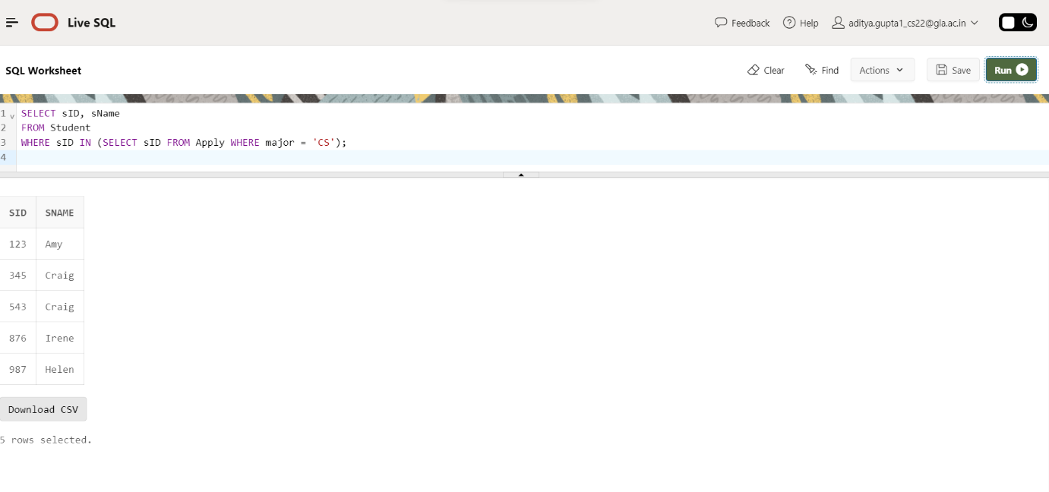

1. Find ID and name of student having same high school size as Jay.

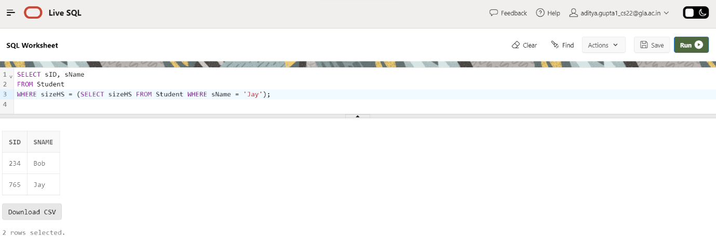

3.Find ID and name of student having same high school size as Jay but result should not include Jay.

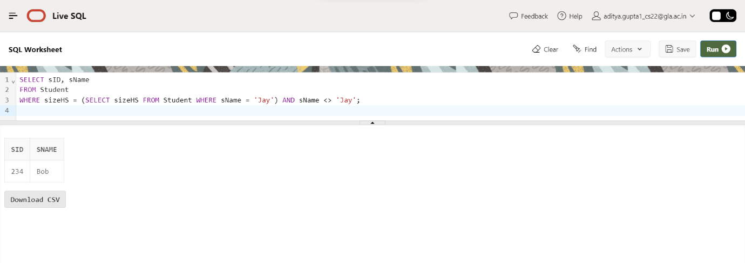

4.Find the name of student with their GPA and Sid whose GPA not equal to GPA of Irene?

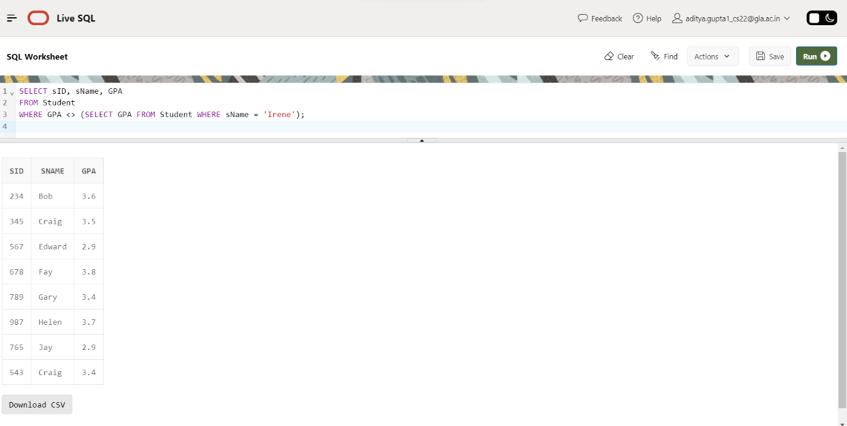

5. Find college where any student having their name started from J have applied?

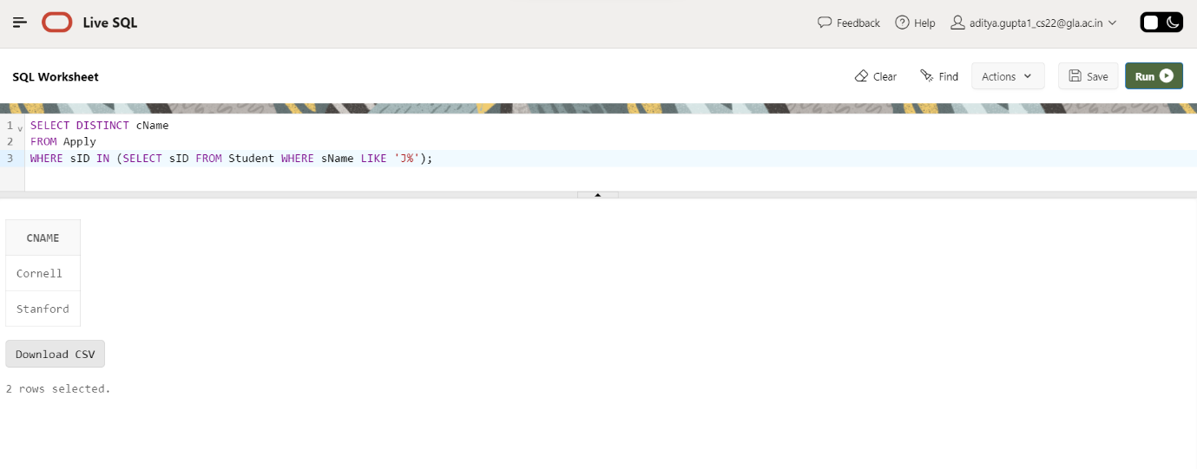

6. Find all different major where Irene has applied?

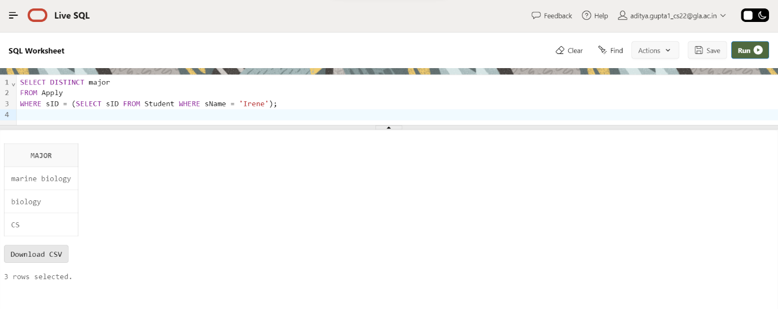

7. Find IDs of student and major who applied in any of major Irene had applied to?

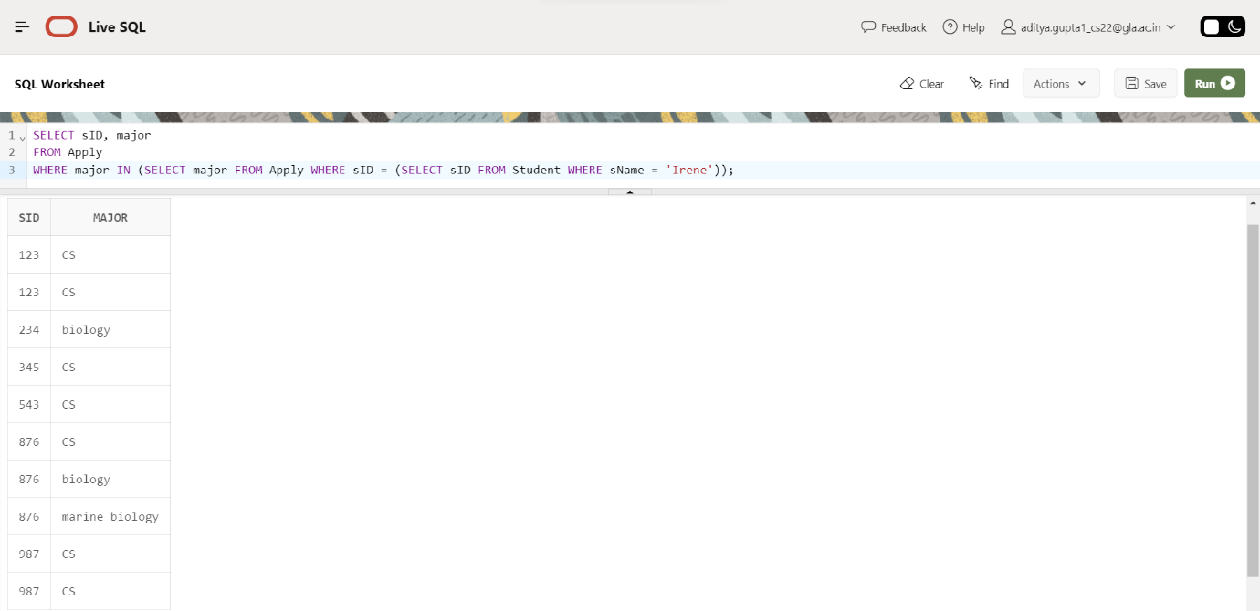

8. Find IDs of student and major who applied in any of major Irene had applied to? But this time exclude Irene sID from the list.

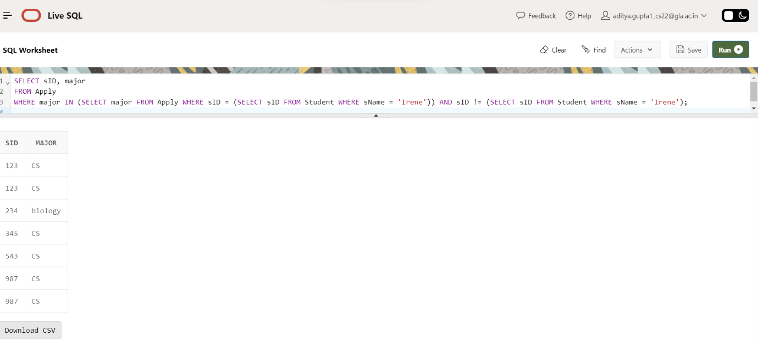

9. Give the number of colleges Jay applied to? (Remember count each college once no matter if he applied to same college twice with different major).

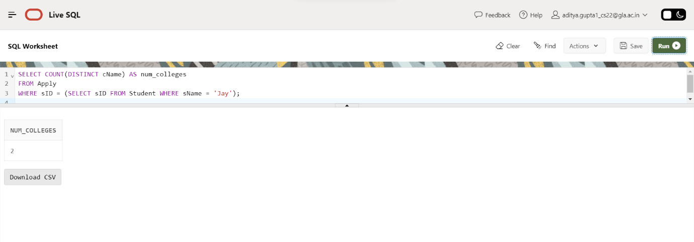

10. Find sID of student who applied to more or same number of college where Jay has applied?

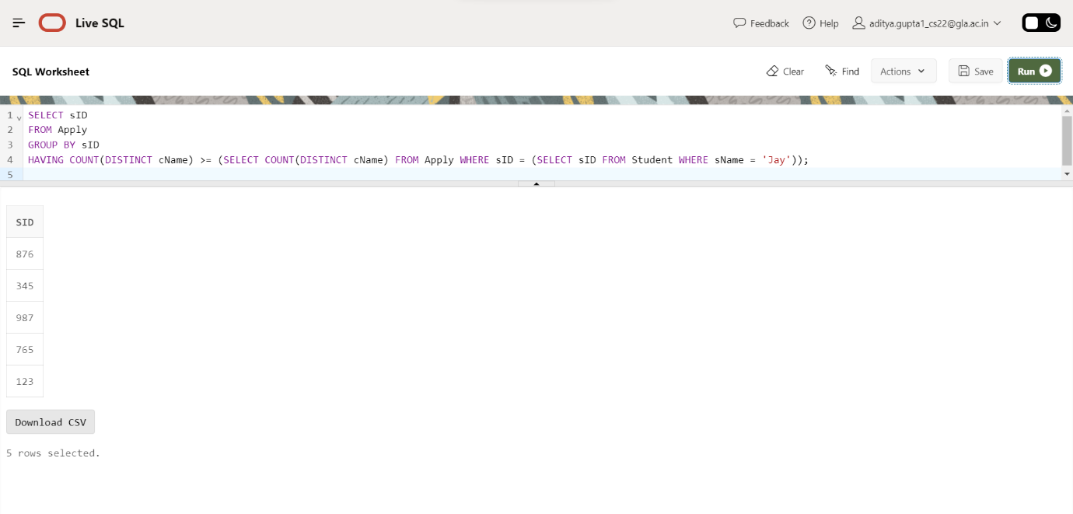

11. Find details of Students who applied to major CS but not applied to major EE? (sID 987, 876, 543 should only be include in result).

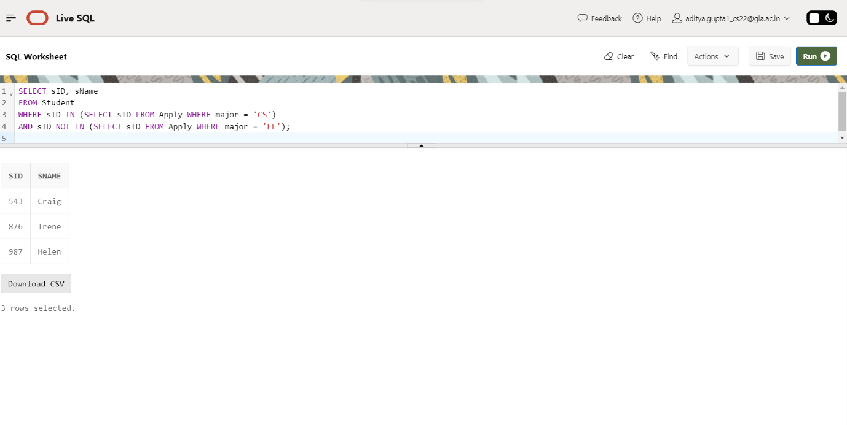

12. All colleges such that some other college is in same state. (Cornell should not be part of result as no other college in New York Hint: use exists).

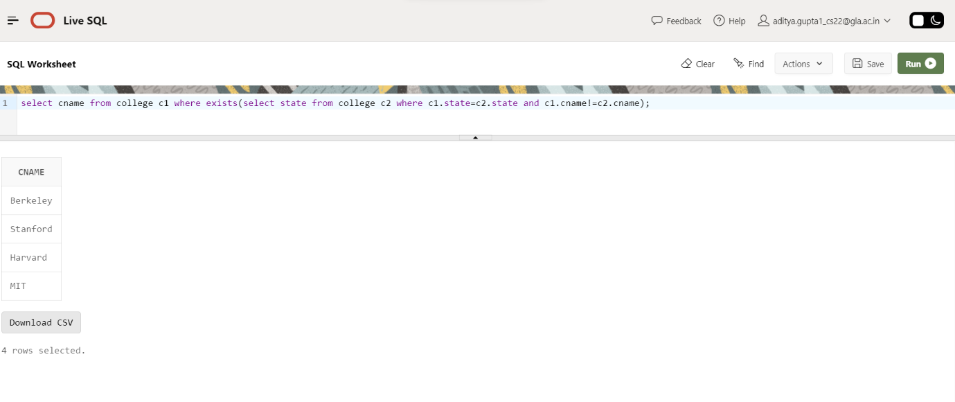

13. Find the college with highest enrollment.

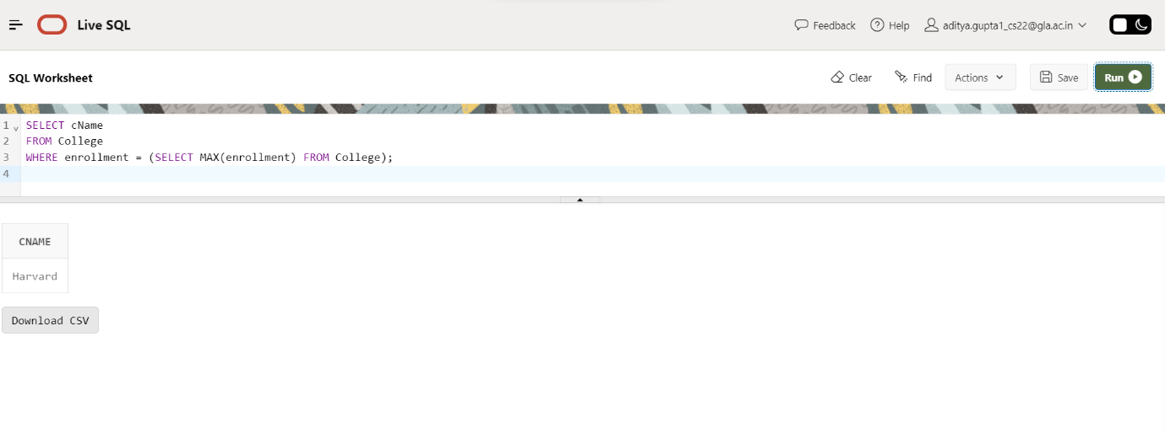

14. Find name of student having lowest GPA.

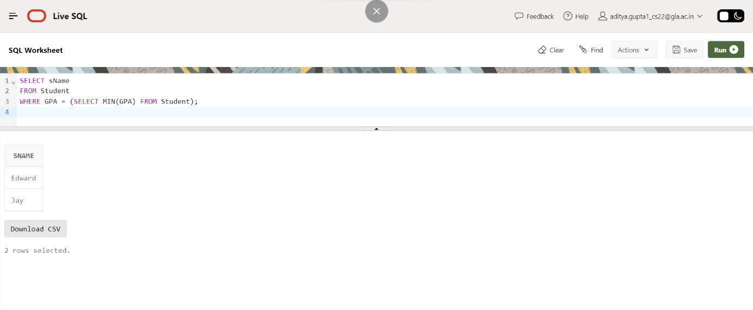

15. Find the most popular major.

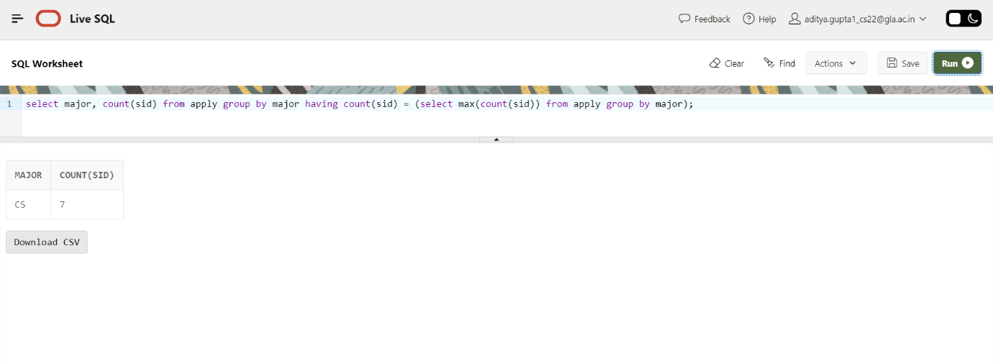

16. Find sID, sName, sizeHS of all students NOT from smallest HS.

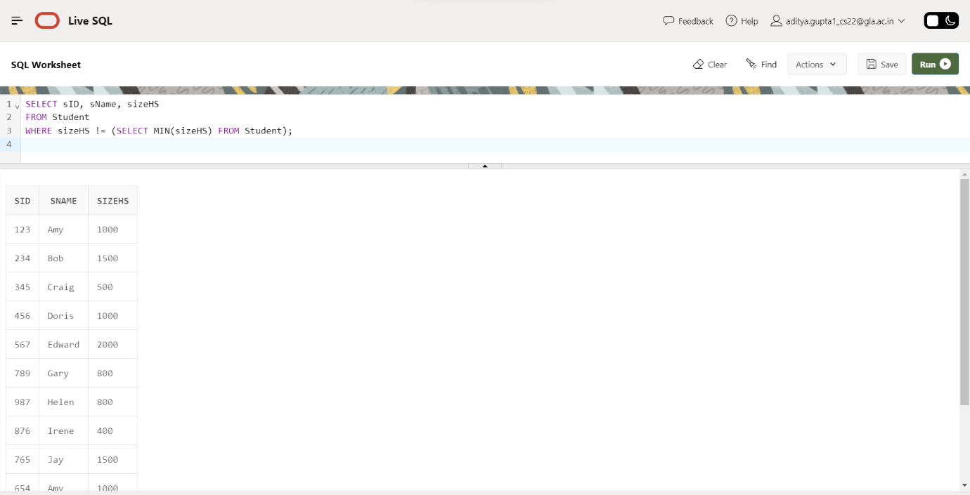

NAME 🡪 ADITYA GUPTA

SECTION 🡪 B

UNIV ROLLNO. 🡪 2215000094

CLASS ROLLNO. 🡪47